Exclusion Statistics

One Sample T-test - Percent Social Chosen Pre Exclusion compared to chance (50%)

| **One Sample T-Test** | | | | | | | | | | | | | | | | | |
| --- | --- | --- | --- | --- | --- | --- | --- | --- | --- | --- | --- | --- | --- | --- | --- | --- | --- |
|  | | | | | | | | | | | | **95% Confidence Interval** | | | |  | |
|  | |  | | **statistic** | | **df** | | **p** | | **Mean difference** | | **Lower** | | **Upper** | | **Cohen's d** | |
| %Social Chosen Pre |  | Student's t |  | 5.09 |  | 16.0 |  | < .001 |  | 0.163 |  | 0.0951 |  | 0.231 |  | 1.23 |  |
| Note. Hₐ population mean ≠ 0.5 | | | | | | | | | | | | | | | | | |
|  | | | | | | | | | | | | | | | | | |

| **Test of Normality (Shapiro-Wilk)** | | | | | |
| --- | --- | --- | --- | --- | --- |
|  |  |  |  |  |  |
|  | | **W** | | **p** | |
| %Social Chosen Pre |  | 0.975 |  | 0.898 |  |
| Note. A low p-value suggests a violation of the assumption of normality | | | | | |
|  | | | | | |

| **Descriptives** | | | | | | | | | | | |
| --- | --- | --- | --- | --- | --- | --- | --- | --- | --- | --- | --- |
|  |  |  |  |  |  |  |  |  |  |  |  |
|  | | **N** | | **Mean** | | **Median** | | **SD** | | **SE** | |
| %Social Chosen Pre |  | 17 |  | 0.663 |  | 0.653 |  | 0.132 |  | 0.0320 |  |
|  | | | | | | | | | | | |

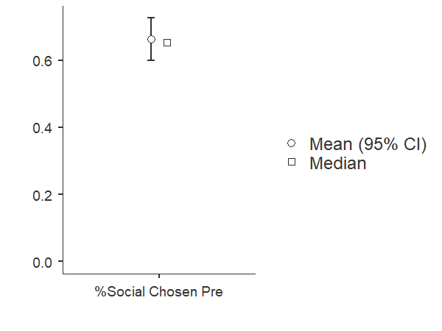

One Sample T-test- Percent Social Chosen Post Exclusion compared to Chance (50%)

| **One Sample T-Test** | | | | | | | | | | | | | | | | | |
| --- | --- | --- | --- | --- | --- | --- | --- | --- | --- | --- | --- | --- | --- | --- | --- | --- | --- |
|  | | | | | | | | | | | | **95% Confidence Interval** | | | |  | |
|  | |  | | **statistic** | | **df** | | **p** | | **Mean difference** | | **Lower** | | **Upper** | | **Cohen's d** | |
| %Social Chosen Post |  | Student's t |  | 3.95 |  | 16.0 |  | 0.001 |  | 0.154 |  | 0.0711 |  | 0.236 |  | 0.957 |  |
| Note. Hₐ population mean ≠ 0.5 | | | | | | | | | | | | | | | | | |
|  | | | | | | | | | | | | | | | | | |

| **Test of Normality (Shapiro-Wilk)** | | | | | |
| --- | --- | --- | --- | --- | --- |
|  |  |  |  |  |  |
|  | | **W** | | **p** | |
| %Social Chosen Post |  | 0.966 |  | 0.748 |  |
| Note. A low p-value suggests a violation of the assumption of normality | | | | | |
|  | | | | | |

| **Descriptives** | | | | | | | | | | | |
| --- | --- | --- | --- | --- | --- | --- | --- | --- | --- | --- | --- |
|  |  |  |  |  |  |  |  |  |  |  |  |
|  | | **N** | | **Mean** | | **Median** | | **SD** | | **SE** | |
| %Social Chosen Post |  | 17 |  | 0.654 |  | 0.653 |  | 0.161 |  | 0.0389 |  |
|  | | | | | | | | | | | |

## Plots

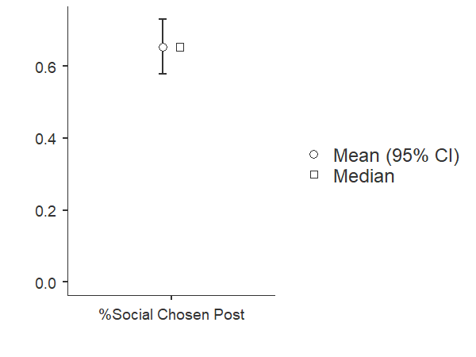

Correlation Between Scores on the AQ and Percent Social Chosen Pre Exclusion

| **Correlation Matrix** | | | | | | | |
| --- | --- | --- | --- | --- | --- | --- | --- |
|  |  |  |  |  |  |  |  |
|  | |  | | **AQ** | | **%Social Chosen Pre** | |
| AQ |  | Pearson's r |  | — |  | -0.412 |  |
|  |  | p-value |  | — |  | 0.101 |  |
|  |  | 95% CI Upper |  | — |  | 0.086 |  |
|  |  | 95% CI Lower |  | — |  | -0.745 |  |
| %Social Chosen Pre |  | Pearson's r |  |  |  | — |  |
|  |  | p-value |  |  |  | — |  |
|  |  | 95% CI Upper |  |  |  | — |  |
|  |  | 95% CI Lower |  |  |  | — |  |
| Note. * p < .05, ** p < .01, *** p < .001 | | | | | | | |
|  | | | | | | | |

**Plot**

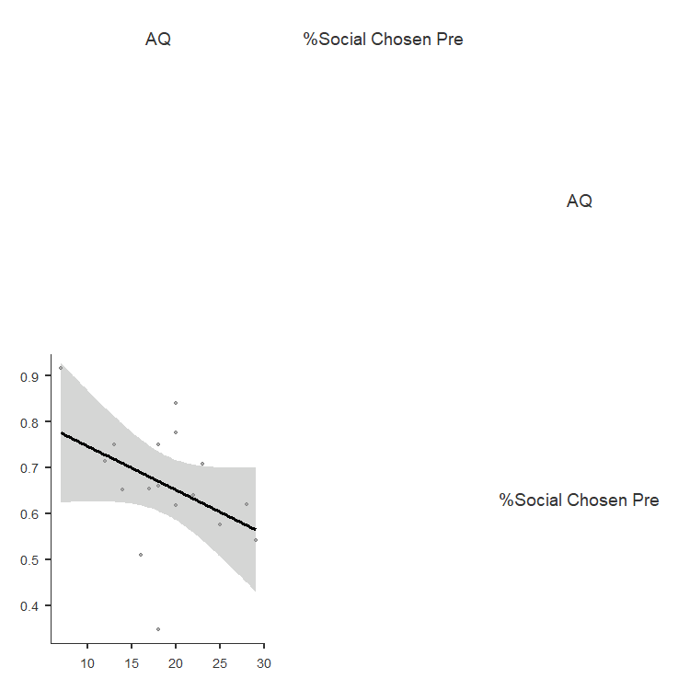

Correlation Between Scores on the AQ and Percent Social Chosen Post Exclusion

| **Correlation Matrix** | | | | | | | |
| --- | --- | --- | --- | --- | --- | --- | --- |
|  |  |  |  |  |  |  |  |
|  | |  | | **AQ** | | **%Social Chosen Post** | |
| AQ |  | Pearson's r |  | — |  | -0.349 |  |
|  |  | p-value |  | — |  | 0.169 |  |
|  |  | 95% CI Upper |  | — |  | 0.158 |  |
|  |  | 95% CI Lower |  | — |  | -0.711 |  |
| %Social Chosen Post |  | Pearson's r |  |  |  | — |  |
|  |  | p-value |  |  |  | — |  |
|  |  | 95% CI Upper |  |  |  | — |  |
|  |  | 95% CI Lower |  |  |  | — |  |
| Note. * p < .05, ** p < .01, *** p < .001 | | | | | | | |
|  | | | | | | | |

## Plot

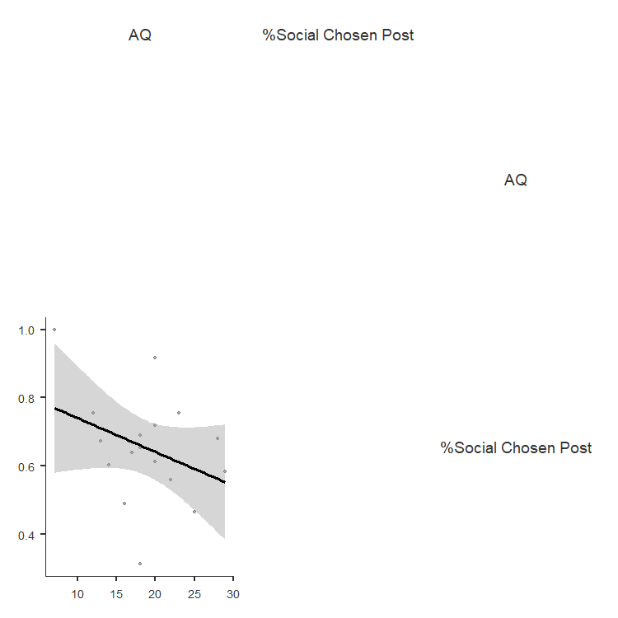

Correlation Between Scores on the MSPSS and Percent Social Chosen Pre Exclusion

| **Correlation Matrix** | | | | | | | |
| --- | --- | --- | --- | --- | --- | --- | --- |
|  |  |  |  |  |  |  |  |
|  | |  | | **MSPSS avg** | | **%Social Chosen Pre** | |
| MSPSS avg |  | Pearson's r |  | — |  | 0.475 |  |
|  |  | p-value |  | — |  | 0.054 |  |
|  |  | 95% CI Upper |  | — |  | 0.778 |  |
|  |  | 95% CI Lower |  | — |  | -0.007 |  |
| %Social Chosen Pre |  | Pearson's r |  |  |  | — |  |
|  |  | p-value |  |  |  | — |  |
|  |  | 95% CI Upper |  |  |  | — |  |
|  |  | 95% CI Lower |  |  |  | — |  |
| Note. * p < .05, ** p < .01, *** p < .001 | | | | | | | |
|  | | | | | | | |

## Plot

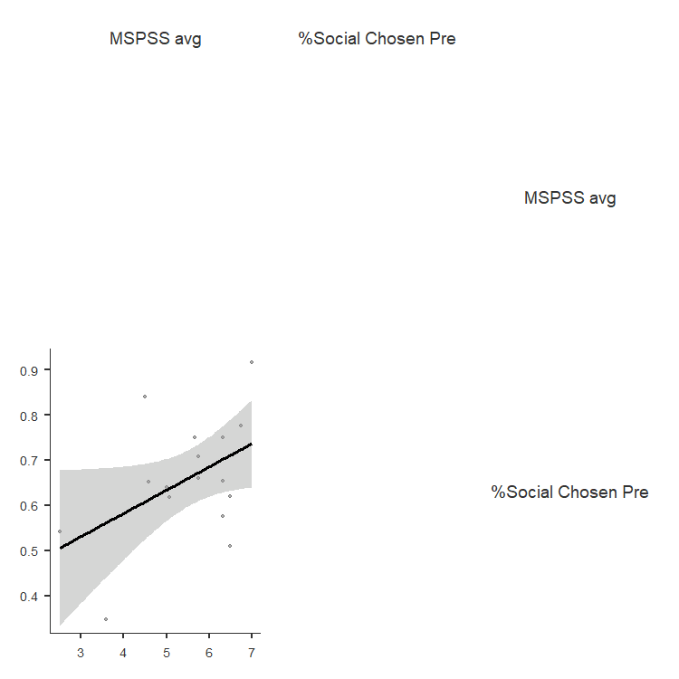

Correlation Between Scores on the MSPSS and Percent Social Chosen Post Exclusion

| **Correlation Matrix** | | | | | | | |
| --- | --- | --- | --- | --- | --- | --- | --- |
|  |  |  |  |  |  |  |  |
|  | |  | | **MSPSS avg** | | **%Social Chosen Post** | |
| MSPSS avg |  | Pearson's r |  | — |  | 0.374 |  |
|  |  | p-value |  | — |  | 0.139 |  |
|  |  | 95% CI Upper |  | — |  | 0.725 |  |
|  |  | 95% CI Lower |  | — |  | -0.130 |  |
| %Social Chosen Post |  | Pearson's r |  |  |  | — |  |
|  |  | p-value |  |  |  | — |  |
|  |  | 95% CI Upper |  |  |  | — |  |
|  |  | 95% CI Lower |  |  |  | — |  |
| Note. * p < .05, ** p < .01, *** p < .001 | | | | | | | |
|  | | | | | | | |

## Plot

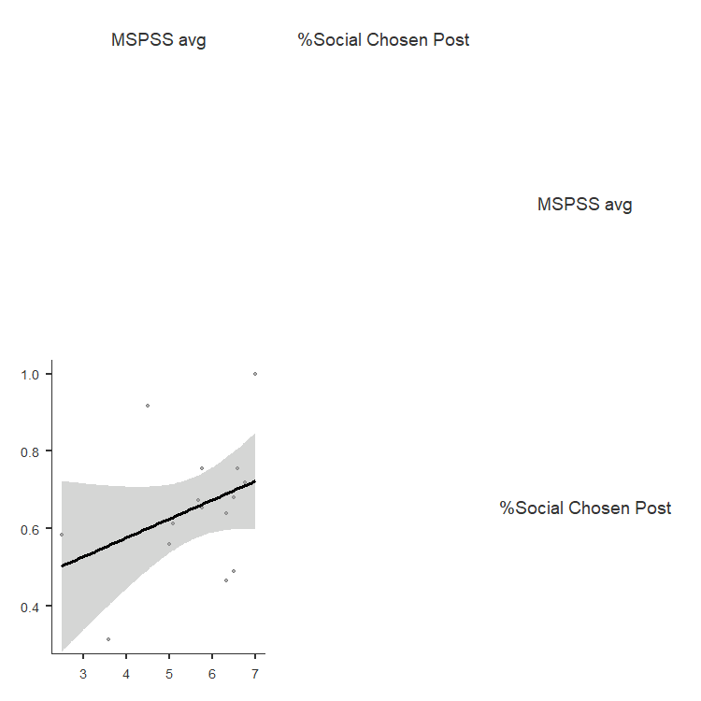

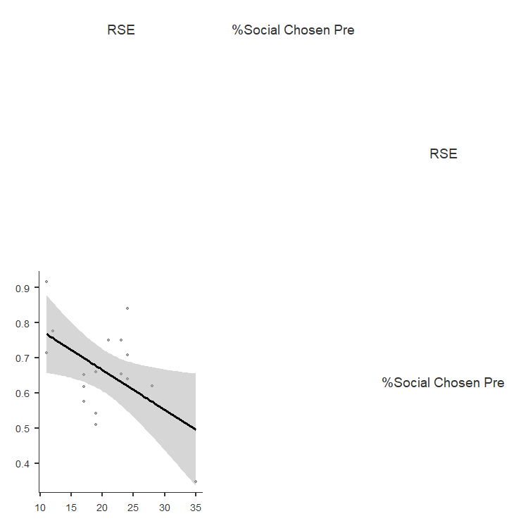Correlation between scores on Rosenberg Self Esteem measure and Percent Social Chosen Pre Exclusion (Lower Scores Signify Higher Self-Esteem)

| **Correlation Matrix** | | | | | | | |
| --- | --- | --- | --- | --- | --- | --- | --- |
|  |  |  |  |  |  |  |  |
|  | |  | | **RSE** | | **%Social Chosen Pre** | |
| RSE |  | Pearson's r |  | — |  | -0.529 | * |
|  |  | p-value |  | — |  | 0.029 |  |
|  |  | 95% CI Upper |  | — |  | -0.065 |  |
|  |  | 95% CI Lower |  | — |  | -0.805 |  |
| %Social Chosen Pre |  | Pearson's r |  |  |  | — |  |
|  |  | p-value |  |  |  | — |  |
|  |  | 95% CI Upper |  |  |  | — |  |
|  |  | 95% CI Lower |  |  |  | — |  |
| Note. * p < .05, ** p < .01, *** p < .001 | | | | | | | |
|  | | | | | | | |

Correlation between scores on Rosenberg Self Esteem measure and Percent Social Chosen Post Exclusion

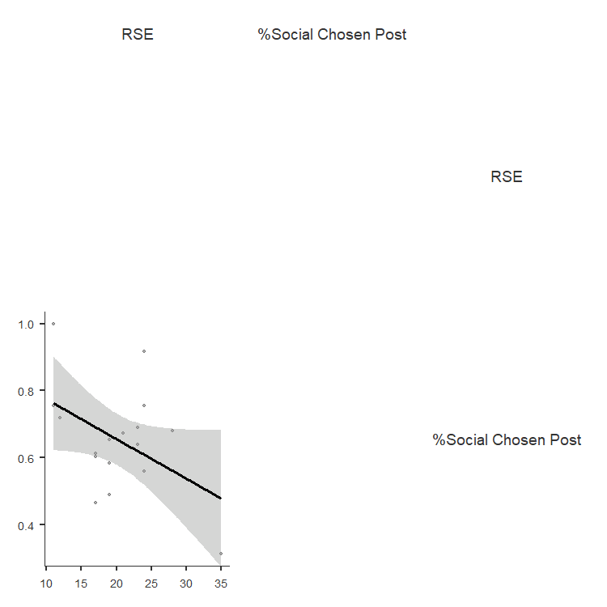

| **Correlation Matrix** | | | | | | | |
| --- | --- | --- | --- | --- | --- | --- | --- |
|  |  |  |  |  |  |  |  |
|  | |  | | **RSE** | | **%Social Chosen Post** | |
| RSE |  | Pearson's r |  | — |  | -0.455 |  |
|  |  | p-value |  | — |  | 0.066 |  |
|  |  | 95% CI Upper |  | — |  | 0.033 |  |
|  |  | 95% CI Lower |  | — |  | -0.768 |  |
| %Social Chosen Post |  | Pearson's r |  |  |  | — |  |
|  |  | p-value |  |  |  | — |  |
|  |  | 95% CI Upper |  |  |  | — |  |
|  |  | 95% CI Lower |  |  |  | — |  |
| Note. * p < .05, ** p < .01, *** p < .001 | | | | | | | |
|  | | | | | | | |